Conservative Vector Fields and the Intersect Rule
Daniel Jaffa

I. Introduction to Conservative Vector Fields
Conservative vector fields, also referred to as gradient fields, are defined as vector fields which represent the gradient of a particular multivariable, scalar-valued function. The function for which a conservative vector field is the gradient is referred to as the potential function. The notion of a potential function roots from the representation of conservative forces with gradient fields, and the corresponding potential function as the associated potential energy of said conservative force (see section IV: Potential Energy and Potential Functions). To formally define conservative vector fields:

Let $F$ be a vector field in $R^{n}$
$F$ is conservative $⟺∃ f | F= ∇f$

To dissect the formal definition, F is defined as a vector field in nth-dimensional real space. In order to classify F as conservative, there must exist some scalar-valued potential function f, such that F is the gradient field of f.
This paper covers theoretical aspects of conservative vector fields, particularly, properties of gradient fields and the derivation of potential functions through the Intersect Rule. Additionally, this paper discusses applications of conservative vector fields in the context of Newtonian mechanics, vector physics, and thermodynamics in real spaces.

II. Properties of Conservative Vector Fields
By the formal definition of conservative vector fields, various properties of gradient fields arise.
The first notable property is entitled the path independence property. This property essentially states that line integrals over conservative fields that start and end at the same point are always equivalent, regardless of the path taken.
To visualize this property, see figure 1, which portrays conservative vector field F in $R^{2}$. Paths C₁ and C₂ both start at point A and end at point B.
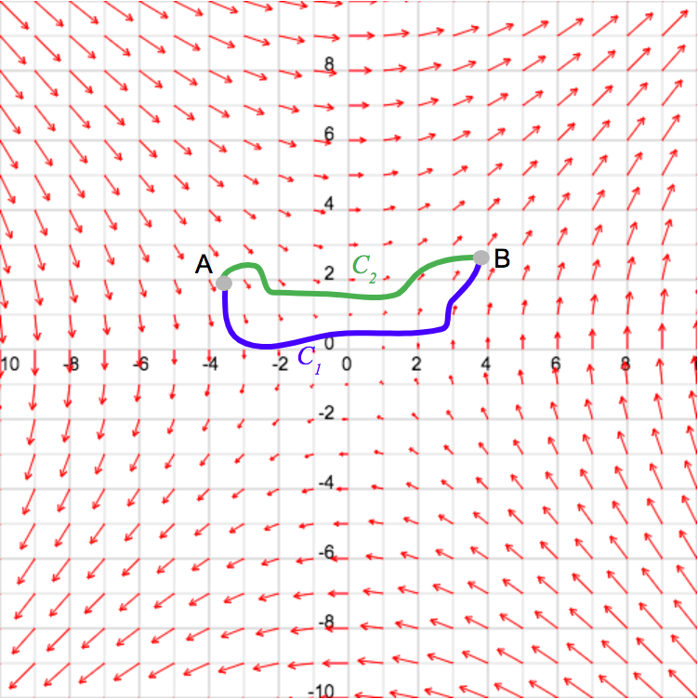
Figure 1: courtesy of Academo Vector Field Plotter

Constructing the line integrals over both paths:

$$\int_{C_{1}}^{ }{F∙d\vec{r}}$$
$$\int_{C_{2}}^{ }{F∙d\vec{r}}$$

To interpret the definite integrals above, consider a fluid particle flowing through this conservative field, along path C₁, whilst a second particle flows along path C₂. The above integrals model the total work done by this conservative force on each molecule, where F represents the force vector, and dr represents a displacement vector with an infinitely miniscule magnitude. Thus, integrating along the paths yields the total work done on each particle flowing through conservative vector field F.
By the formal definition of conservative vector fields, F must be the gradient of some scalar valued potential function, f. Thus, the line integrals can be rewritten as:

$$\int_{C_{1}}^{ }{F∙d\vec{r}}=\int_{A}^{B}{∇f}∙d\vec{r}$$
$$\int_{C_{2}}^{ }{F∙d\vec{r}}=\int_{A}^{B}{∇f}∙d\vec{r}$$

Considering that the integrals are expressed as gradients of scalar-valued functions, recall the gradient theorem to evaluate the definite integrals:

$$\int_{C_{1}}^{ }{F∙d\vec{r}}=\int_{A}^{B}{∇f}∙d\vec{r}=f\left(B\right)-f(A)$$
$$\int_{C_{2}}^{ }{F∙d\vec{r}}=\int_{A}^{B}{∇f}∙d\vec{r}=f\left(B\right)-f(A)$$
Thus:

$$\int_{C_{1}}^{ }{F∙d\vec{r}}=\int_{C_{2}}^{ }{F∙d\vec{r}}=f\left(B\right)-f(A)$$
Therefore, if F is defined as a conservative vector field, all line integrals are dependent solely on the starting and ending points, rather than the path taken.
The second notable property of gradient fields is that all line integrals over simply closed loops are always equal to zero, regardless of the orientation of the loop.
Reverting to the prior scenario, see figure 2, which portrays the previous gradient field, however, paths C₁ and C₂ are simply closed at point A. It is crucial to note that path C₁ is positively oriented whilst path C₂ is negatively oriented.

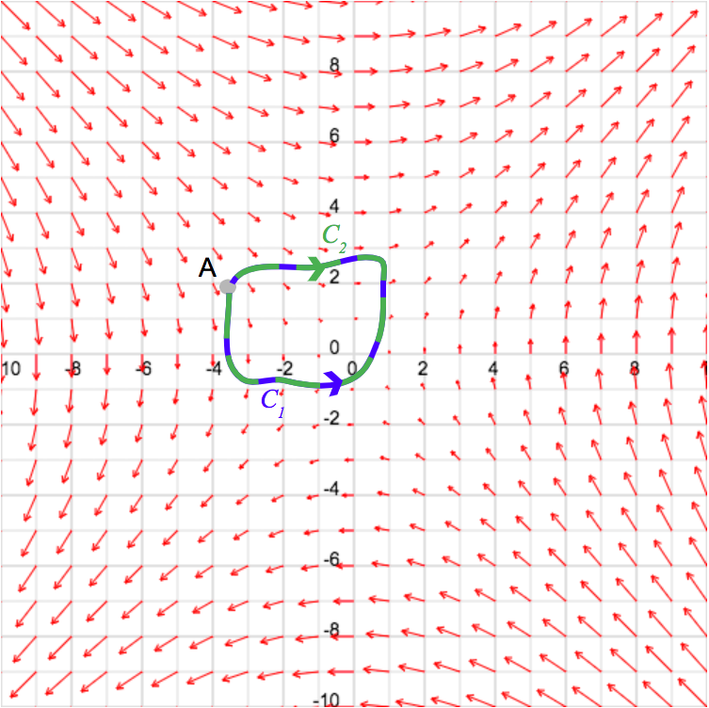
Figure 2: courtesy of Academo Vector Field Plotter

When constructing the line integrals, it is pivotal to recall that for all line integrals over the same closed loop, negative orientation flips the sign of the line integral. Additionally, recall the path independence property:

$$\oint_{C_{1}}^{ }{F∙d\vec{r}}=-\oint_{C_{2}}^{ }{F∙d\vec{r}}$$

By the gradient theorem:

$$\oint_{C_{1}}^{ }{F∙d\vec{r}}=-\oint_{C_{2}}^{ }{F∙d\vec{r}} ⇒ \oint_{A}^{A }{∇f∙d\vec{r}}=-\oint_{A}^{A }{∇f∙d\vec{r}}$$

Evaluating the integrals:

$$f\left(A\right)-f\left(A\right)=-\left(f\left(A\right)-f\left(A\right)\right)=0$$

Therefore, if F is a conservative field, line integrals over simply closed loops are always equal to zero, regardless of the orientation.
The third and final significant property of gradient fields is the irrotational property, which states that the curl of all conservative vector fields is always zero.
To prove this property, consider conservative vector field F in $R^{2}$:

$$F(x,y)=P(x,y)\hat{i}+Q(x,y)\hat{j}$$
$$F=∇f$$

F can be redefined in terms of f, as F is the gradient of scalar-valued function f:

$$F(x,y)=\frac{∂f}{∂x}\hat{i}+\frac{∂f}{∂y}\hat{j}$$

Calculating the two-dimensional curl of F:

$$Curl\left(F\right)=∇×∇f=det\left[\begin{matrix}\frac{∂}{∂x} & \frac{∂f}{∂x} \\ \frac{∂}{∂y} & \frac{∂f}{∂y}\end{matrix}\right]=\frac{∂^{2}f}{∂y∂x}-\frac{∂^{2}f}{∂x∂y}$$

Recall Clairaut’s Theorem, which states that: “If the second partial derivatives of a function are continuous, then the order of differentiation is immaterial,” (Clairaut 1740). Assuming that the second partial derivatives of f are continuous:

$$\frac{∂^{2}f}{∂x∂y}-\frac{∂^{2}f}{∂y∂x}=\frac{∂^{2}f}{∂x∂y}-\frac{∂^{2}f}{∂x∂y}=0$$
⇓
$$\frac{∂Q}{∂x}-\frac{∂P}{∂y}=0 ⟹ \frac{∂Q}{∂x}=\frac{∂P}{∂y}$$

Thus, the curl of a conservative vector field in two-dimensions is always zero. In three dimensions, however, it is crucial to clarify that the three-dimensional curl of a conservative vector field produces the zero vector, as opposed to the two-dimensional curl yielding the scalar zero. Therefore, in three-dimensions:

$$Curl\left(F\right)=\vec{0}$$

The above properties are directly analogous to the properties of conservative forces in Newtonian mechanics, as demonstrated in the following sections.

III. Conservative Vector Fields as Conservative Force
As briefly mentioned in section II, the line integral within a conservative vector field may be interpreted as the total work done by a conservative force, represented by vector field F, on a particle flowing through the field.
Vector fields depict force fields, in which each point is associated with a vector that represents a particular force acting upon a particle at that point in space. Consider figure 3, which portrays an arbitrary three-dimensional vector field, F₁. At each point in the input space, a corresponding three-dimensional vector is output. If F₁ represents a particular force field, each vector conveys the force acting upon an object in the force field. This interpretation holds true for all vector fields.
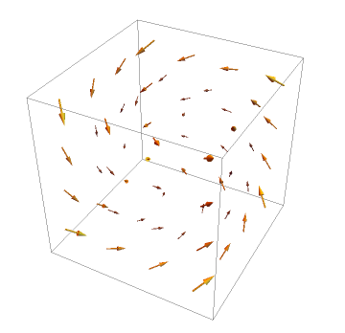
Figure 3: courtesy of Wolfram Demonstrations Project 3D Vector Field Plotter

With regards to conservative vector fields, each vector in the output space describes a particular conservative force acting upon an object in the force field. Thus, conservative vector fields are utilized to represent conservative forces.
Concerning line integrals within conservative vector fields, the path independence property holds true with the interpretation of a gradient field as a conservative force field. Conservative forces are defined as forces for which the work done on an object by that force is independent of the path taken, and exclusively depends on the start and end points of the path. This is directly analogous to the path independence property of gradient fields, as line integrals in gradient fields are equivalent regardless of the path taken, and solely based on the start and end points. Thus, if a force is conservative, the associated force vector field must also be conservative.

IV. Potential Energy and Potential Functions
All conservative forces hold an associated potential energy. Potential energy is defined as stored energy which exists due to an object’s position with respect to the particular zero position, and possesses the potential to release in the form of kinetic energy upon a conservative force acting on the object. Essentially, when a conservative force acts upon an object, the potential energy associated with that conservative force converts to kinetic energy, as the object falls in motion.
Conservative forces acting upon an object have the tendency to shift the object into a state of lesser potential energy. By acting on the object, a conservative force releases potential energy in the form of kinetic energy on the object, as net work is done by the force. Put simply, as potential energy is released as kinetic energy, potential energy decreases, as kinetic energy consequently increases.
To model this relationship, consider what is depicted by a gradient field. Let F be the gradient field of scalar-valued function f. Gradient fields associate vectors with all points in the input space. The vectors within F point in the direction of greatest increase of function f, also referred to as the direction of steepest ascent. Essentially, each vector indicates the direction in which function f increases the greatest, at each particular point.
To contextualize this, consider figure 4, which depicts the three-dimensional graph of $f\left(x,y\right)=-x^{2}-y^{2}$. The function possesses a global maximum at point (0,0,0). On the gradient field of f, as depicted in figure 5, this translates to the zero vector, as, at this particular point, there does not exist a direction in which the function increases, as this particular point is a global maximum. Essentially, in all other directions, f decreases, thus, the gradient vector at this particular point is the zero vector.
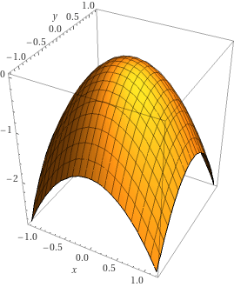

Figure 4: courtesy of Wolfram Alpha 3D Plot
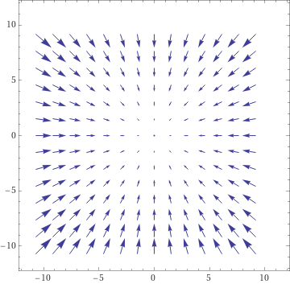

Figure 5: courtesy of Wolfram Alpha Vector Field Plotter

With respect to conservative forces and potential energy, as previously mentioned, conservative forces tend to shift objects acted upon into a state of lesser potential energy, and, as a result, greater kinetic energy. To model the relationship between a conservative force field and its associated potential energy, contemplate the relationship between a function and its gradient field. The vectors of a gradient field point in the direction of greatest increase, whilst conservative forces attempt to shift the acted upon object in the direction of greatest decrease in potential energy, to maximize the kinetic energy.
Thus, to model the relationship, consider conservative vector field F, which models an arbitrary conservative force. Let P_{F} be a scalar-valued function which represents the associated potential energy with conservative force field F. By this, the following formula can be derived:
$$F=-∇P_{F}$$

The incentive behind the negative sign on the gradient of the potential energy is that the vectors in a conservative force field point in the direction of greatest decrease, at all given input points. Hence, the negative sign abides by the tendency of conservative forces to minimize potential energy, and maximize kinetic energy.
To express this relationship in a form analogous to the formal definition of gradient fields, a function scalar valued function, E_{P} can be constructed, such that:

$$E_{P}=-P_{F}$$

The gradient of the above functions:

$$∇E_{P}=\left[\begin{aligned}\frac{∂E_{P}}{∂x_{1}} \\ \frac{\begin{aligned}⋮ \\ ∂E_{P}\end{aligned}}{∂x_{n}}\end{aligned}\right] ∇P_{F}=\left[\begin{aligned}\frac{∂P_{F}}{∂x_{1}} \\ \frac{\begin{aligned}⋮ \\ ∂P_{F}\end{aligned}}{∂x_{n}}\end{aligned}\right]$$

Substitute –P_{F} for E_{P}:

$$∇E_{P}=∇\left(-P_{F}\right)=\left[\begin{aligned}\frac{∂\left(-P_{F}\right)}{∂x_{1}} \\ \frac{\begin{aligned}⋮ \\ ∂\left(-P_{F}\right)\end{aligned}}{∂x_{n}}\end{aligned}\right]=-\left[\begin{aligned}\frac{∂P_{F}}{∂x_{1}} \\ \frac{\begin{aligned}⋮ \\ ∂P_{F}\end{aligned}}{∂x_{n}}\end{aligned}\right]=-∇P_{F}$$

Thus, the relationship between a conservative force field F and its associated potential energy function, P_{F} can be expressed as:

$$F=∇E_{P}$$

Where, E_{P} is the negative potential energy function of F.
By the notion of conservative force fields being the gradient of the negative associated potential energy function emerges the concept of a conservative field being the gradient of an associated potential function.

V. Deriving Potential Functions and the Intersect Rule
To restate the formal definition of a conservative vector field:

Let $F$ be a vector field in $R^{n}$
$F$ is conservative $⟺∃ f | F= ∇f$

The function for which conservative field F is the gradient is referred to as the potential function, rooting from the notion of potential energy, as discussed above. When deriving potential functions, it is crucial to revert to the formal definition of gradient fields. As a contextualization of this concept, consider conservative vector field F₀:

$$F_{0}\left(x,y\right)=\left[\begin{aligned}P(x,y) \\ Q(x,y)\end{aligned}\right]$$

It has been established that F₀ is conservative, thus, F₀ may be expressed in terms of scalar-valued potential function f:
$$F_{0}\left(x,y\right)=\left[\begin{aligned}P(x,y) \\ Q(x,y)\end{aligned}\right]=\left[\begin{aligned}\frac{∂f}{∂x} \\ \frac{∂f}{∂y}\end{aligned}\right]$$

By this definition emerges a system of equations:

$$\left\{\begin{aligned}P\left(x,y\right)=\frac{∂f}{∂x} \\ Q\left(x,y\right)=\frac{∂f}{∂y}\end{aligned}\right.$$

Although the following step lacks mathematical rigor, it provides a general intuition behind the derivation of potential functions. Essentially, consider multiplying both sides of the first equation by the partial-x operator, whilst also multiplying both sides of the second equation by the partial-y operator.

$$\left\{\begin{aligned}P\left(x,y\right)∂x=∂f \\ Q\left(x,y\right)∂y=∂f\end{aligned}\right.$$

To solve the system, integrate the above equations:

$$\left\{\begin{aligned}\int{P\left(x,y\right)dx}=\int{df} \\ \int{Q\left(x,y\right)dy}=\int{df}\end{aligned}\right.$$

Note that the partial differential operators were converted to differential operators, which, yet again, lacks mathematical rigor, however, is justifiable for the purpose of deriving potential functions. Upon evaluating the indefinite integrals, the following solutions are produced:

$$\left\{\begin{aligned}\int{P\left(x,y\right)dx}=f_{1}\left(x\right)f_{2}\left(y\right)+f_{3}\left(x\right)+g(y) \\ \int{Q\left(x,y\right)dy}=f_{4}\left(x\right)f_{5}\left(y\right)+g_{1}\left(y\right)+f(x)\end{aligned}\right.$$
Where:
f₁f₂ is a function described as the product of a pure function of x and a pure function of y
f₄f₅ is a function described as the product of a pure function of x and a pure function of y
f₃ is a pure function of x, derived by the indefinite integral
f is an arbitrary function of x lost by the partial derivative operator
g is an arbitrary function of y lost by the partial derivative operator
g₁ is a pure function of y derived by the indefinite integral.
Considering F₀ is described as conservative, it is fair to conclude that:

$$f_{1}\left(x\right)f_{2}\left(y\right)=f_{4}\left(x\right)f_{5}\left(y\right)$$

The above functions were both derived by the indefinite integrals, as, when integrating with respect to x, any pure function of y multiplied by a pure function of x acts as a coefficient on the pure function of x. Similarly, when integrating with respect to y, any pure function of x multiplied by a pure function of y acts as a coefficient on the pure function of y. Thus, when integrating, the above statement must hold true in order for the definition of conservative vector fields to hold true.
Another conclusion that may be made based on the above integrals:

$$f_{3}\left(x\right)=f(x)$$
$$g_{1}\left(y\right)=g(y)$$

This statement holds true, as, when differentiating with respect to x, all pure functions of y that are not coefficients on pure functions of x are lost due to the partial derivative operator. Thus, when integrating with respect to x, it is crucial to add an arbitrary function of y lost when taking the partial derivative. The same holds true for pure functions of x that are not coefficients on pure functions of y when differentiating and integrating with respect to y.
Thus, the potential function of gradient field F may be expressed as:

$$f\left(x,y\right)=f_{1}\left(x\right)f_{2}\left(y\right)+f_{3}\left(x\right)+g_{1}\left(y\right)$$

Although deriving potential functions is relatively straightforward in $R^{3}$, as the dimensions increase, deriving potential functions by simple deduction proves increasingly difficult and error bound. Additionally, deduction for deriving potential functions lacks mathematical rigor, and requires informal methods.
To formally and rigorously derive potential functions, emerges the Intersect Rule. The intuition behind the intersect rule roots in mathematical deduction. Revert to the previous case in $R^{3}$, particularly, when integrating both equations in the system:

$$\left\{\begin{aligned}\int{P\left(x,y\right)dx}=\int{df} \\ \int{Q\left(x,y\right)dy}=\int{df}\end{aligned}\right.$$

As stated above, both integrals yield the product of pure functions of x and y, in addition to pure functions of x and pure functions of y. The Intersect Rule states that to derive the final potential function:

$$f(x,y)=\int{P\left(x,y\right)dx}\bigcap{\int{Q\left(x,y\right)dy}}$$

Essentially, the potential function of F is given by the intersection of the indefinite integrals above. To confirm this conjecture, consider the mathematical deduction utilized to derive the potential function in the first scenario:

$$\left\{\begin{aligned}\int{P\left(x,y\right)dx}=f_{1}\left(x\right)f_{2}\left(y\right)+f_{3}\left(x\right)+g(y) \\ \int{Q\left(x,y\right)dy}=f_{4}\left(x\right)f_{5}\left(y\right)+g_{1}\left(y\right)+f(x)\end{aligned}\right.⟹f\left(x,y\right)=f_{1}\left(x\right)f_{2}\left(y\right)+f_{3}\left(x\right)+g_{1}\left(y\right)$$

It was deduced that both integrals yield a function described as the product of a pure function of x and a pure function of y, by the formal definition of gradient fields. Moreover, considering F is an established gradient field, the arbitrary pure function of y lost by the partial derivative operator in the first integral matched the concrete pure function of y produced by the second integral. The above holds true for the pure function of x lost by the partial derivative operator in the second equation, and derived by the first integral.
Put simply, the Intersect Rule treats the indefinite integral as a set of infinitely many elements, all of which satisfy the indefinite integral. Concretely, in the case above, define set $Λ_{1}$ and set $Λ_{2}$:

$$Λ_{1}=\left\{ρ_{1}\left(x,y\right)| ρ_{1}\left(x,y\right)=\int{P\left(x,y\right)dx}\right\}$$
$$Λ_{2}=\left\{ρ_{2}\left(x,y\right)| ρ_{2}\left(x,y\right)=\int{Q\left(x,y\right)dy}\right\}$$

Let $ρ_{1}$ be an arbitrary function of x and y that satisfies the first indefinite integral. Let $ρ_{2}$ be an arbitrary function of x and y that satisfies the indefinite integral. By this definition, set $Λ_{1}$ can be described as the set of all functions, $ρ_{1}$, that satisfies the first indefinite integral. Similarly, set $Λ_{2}$ can be described as the set of all functions,$ρ_{2}$, that satisfies the second indefinite integral.
As a result, the potential function of F can be expressed as the intersection of set $Λ_{1}$ and set $Λ_{2}$. The intersection of these sets yields the potential function of F, which is, essentially, a formal, rigorous definition of the mathematical deduction initially utilized.
Thus to formally define the Intersect Rule, let F be a conservative vector field in $R^{n}$, described as follows:
$$F(x_{1},x_{2},…,x_{n})=\left[\begin{aligned}γ_{1}(x_{1},x_{2},…,x_{n}) \\ γ_{2}(x_{1},x_{2},…,x_{n}) \\ ⋮ \\ γ_{n}(x_{1},x_{2},…,x_{n})\end{aligned}\right]$$

The Intersect Rule defines the potential function of F as:

$$f=\bigcap_{i=1}^{n}{\int{γ_{i}dx_{i}}}$$

By this definition, another principle emerges. If the Intersect Rule yields the null set, as in, the set of indefinite integrals never intersect, this implies that the vector field is not conservative, as there does not exist a potential function for which the vector field is the gradient. To formally convey this principle:

$$If \bigcap_{i=1}^{n}{\int{γ_{i}dx_{i}}}=∅ ⟹∄ f | F=∇f$$
VI. Conclusion
Conservative vector fields represent conservative force fields, and are the gradient of a particular potential function. Various properties of gradient fields are directly analogous to properties of conservative forces, thus, if an arbitrary force is conservative, this implies that the associated force vector field must also be conservative. The intersect rule provides not only a unique shortcut for deriving potential functions of conservative vector fields in all nth-dimensional real space, however, a method for determining if a vector field is conservative.

