Yield and Volatility of TSMC under this Turn’s Interest Rate Policy
Anjia Sun
Delaware County Christian School, Newtown Square, 19301, United States
ASun85@dccs.org
Abstract. The Federal Reserve Board of Governors made the decision to increase the target range for the federal funds rate for the fourth time in 2022 on July 27. Due to the fact that many global events took place, such as the Covid-19 Pandemic, the China-US trade war, and the Russia-Ukraine war, these changes brought about the worst economic collapse seen in the United States since the Great Depression, which led to the highest inflation rate seen in the 21st century. The decision was made by the government of the United States to raise the federal funds rate in order to reduce inflation and achieve market stability and smoothness. The effects of rate rise by the Federal Reserve are substantial in a variety of contexts, particularly in the semiconductor sector. This research chose a well-known Chinese company, Taiwan Semiconductor Manufacturing Company, and intercepted its stock data from 2019 to 2022. It then used both the VAR model and the ARMA-GARCH model to simulate and analyze the data, studied the influence of Fed rate hikes on this Chinese semiconductor company’s yield and volatility rate, also made a future prediction of this Chinese semiconductor company’s development, and finally offered some comments and suggestions for the company.
Keywords: TSMC, Interest Rate; Capital Flows.

Introduction

Background
The Federal Reserve increased interest rates by 0.75 percentage point on June 15, 2022. This was the third increase in rates this year and the highest increase since 1994. This action is being taken in an effort to combat the inflation rate that is now running at its highest level in over 40 years. The Federal Reserve is striving for a "soft landing" in which inflation is brought under control and the economy continues to expand without experiencing a downturn. The Federal Reserve has been steadily raising interest rates over the last several months in an effort to maintain price stability without having a negative impact on employment. However, when the Fed has been forced to increase interest rates rapidly in the past, it has been difficult to prevent economic downturns. Because interest rates indicate the cost of borrowing money, when the Federal Reserve increases the target rate, it causes the cost of borrowing money to increase. Alterations to the federal funds rate would also have an effect on the value of the United States dollar. Whenever the Federal Reserve raises the interest rate on the federal funds rate, it will almost always result in higher interest rates across the board. Because of the higher yields, investment money from investors in other countries who are looking for better returns on bonds and other interest-rate products is drawn to the country. This economic phenomenon is most readily apparent in the market for exported goods, in particular those sectors in which exporters lack both initiative and priority. This economic dynamic is best shown by the example of TSMC, a Chinese corporation that manufactures semiconductors.
Why TSMC has a strong reaction under the U.S. Fed rate hike policy?
First, Taiwan Semiconductor Manufacturing Company, a near monopoly at the bleeding edge, is the world's most advanced contract chipmaker. It specializes in the most complicated part of the semiconductor industry. Due to the global shortage of chips, the manufacturing industry's demand for chips has increased dramatically leading to increased sales for TSMC. It controls more than half the global market for made-to-order chips and has an even tighter stranglehold on the most advanced processors, with more than 90% of market share by some estimates. Second, Taiwan's unique geographical situation has afforded the island area a distinct political status with respect to both China and the United States. Bown indicated that because of the specialty of the semiconductor industry and scarcity of chips, the governments of both the United States and China are engaged in a competition to get this resource and led a unique influence on the semiconductor industry in China [1]. Particularly for the Chinese government, China has been investing billions of dollars in an attempt to solve the challenge of producing semiconductors, but the results have been mixed, with several notable failures occurring over the previous few years. As a result of this, TSMC, which was previously a very unremarkable services firm, has been catapulted into the heart of a worldwide struggle over the direction that technology will go.
Although the Fed's rate rises will have some effect on the semiconductor sector and technology market, it is possible that these effects will not be durable. This article predicts, based on a review of existing literature and data, that the TSMC trade dispute will have a short-term impact on the semiconductor industry, but that Fed rate hikes will not cause long-term fluctuations in the semiconductor industry due to the invisible hand of the economic market.
The remaining portions of this document are structured as follows: Part 2 is the literature review, which includes pertinent research on the causes and impacts of the change in Fed fund rate and how the change in Fed fund rate changes affects the semiconductor industry, and it concludes with a summary of the literature review. Then, after that, it is followed by Part 3, which makes use of certain data and images as an aid and focuses on the impact of the Fed fund rate changes on the semiconductor industry and illustrates the impact of the Fed rate hikes on the semiconductor industry. After that, the next phase will then carry out an VAR and ARMA-GARCH model analysis using the data that is pertinent to the investigation. The results of the empirical analysis are used to demonstrate the impact that an increase in the Fed fund rate has had on TSMC. Finally, these results are used to draw conclusions, make predictions, and offer feasible and innovative suggestions for the continued growth of the semiconductor industry.

Literature Review
Since the beginning of the 1990s, there have been a total of 44 instances when the Federal Reserve has raised interest rates in an effort to bring down inflation and establish market stability and smoothness. Bivens believed that Fed made the decision of the Fed rate hikes only based on price inflation rate and they did not pay attention on actual economic data, because current unemployment rate remains significantly higher than what it reached in 1999 and 2000 [2]. However, Rahman argued the immediate impact of an increase in interest rates will be felt in the form of higher costs for both consumers and businesses. In addition, an increase in interest rates will have the effect of increasing the demand for the dollar because more people will invest in assets that are denominated in dollars [3]. As a consequence of this, the economic market was being significantly impacted by the Federal Reserve's decision to raise interest rates. According to Wray's findings, he felt that the Federal Reserve was working toward a neutral interest rate, which is one that neither leads to an increase in inflation nor a decrease in economic growth. However, there is not much to be gained by pursuing such a fanciful objective [4]. On the other hand, Feldstein's study focuses specifically on investigating the motivation behind the Federal Reserve's decision to raise interest rates. He added that the Federal Open Market Committee's goal in increasing interest rates is to restore real rates to a "neutral" level, which is a level that neither boosts nor lowers total demand [5]. In addition to this, the stock market was being directly affected by the Fed's decision to raise interest rates. Ogawa stated that the portfolio outflows from emerging market countries significantly deteriorate the domestic equity prices and depreciate the home currencies against the US dollar. As a result, the portfolio outflows from emerging market countries are reinforced and become more serious, particularly among the emerging market countries that have the highly regional economic nexus [6]. Taiwan, which has a difficult geographical situation and political status, would benefit from this economic approach because of its favorable position. However, Jin stated that the increase in interest rates by the Fed would have a mixed influence on China's import and export trade, and that it will be difficult to determine the net direction of the trade. The rise in the Federal Reserve's target range for short-term interest rates has a supporting impact on the exchange rate of the US dollar, which is beneficial to the growth of exports from China to the US. The restrictive trade policy, on the other hand, suggests that a growth in China's exports to the United States should not be clear [7].
In general, research on the reasons, methods, and implications of Fed rate rises has been rather widely investigated; nevertheless, research on the impact of the hikes on the semiconductor sector is still quite limited. It is challenging to speculate on how the semiconductor business will evolve in the next few years. Therefore, the purpose of this paper is to do more to fill the gaps in the research in this area and to use empirical data to demonstrate the impact of the Fed rate hikes on the current and long-term development of the semiconductor market.

Research Design

Data Sources
This paper searches and obtains data on the semiconductor industry by using the Choice financial terminal which is a search engine and in conjunction with Yahoo Finance [8, 9]. The paper used the data of stock price of TSMC and exchange price of USD to NTD from June, 2021 to the present as a data source for empirical analysis to investigate the influences of the Fed rate hikes on semiconductor industry.

ADF test
After completing the model construction, the ADF test is applied in this situation to test stationarity of the data. By plugging the data into Stata and performing the ADF test, we can see from Table 1 that the p-value for the log-returns is 0, which is less than 0.1, so we can reject the null hypothesis and in favor of the alternative hypothesis. thus, the data is stationary.
Table 1 ADF test
Variables | t-statistic | p-value
Price
TSMC | -2.279 | 0.4456
Exchange rate | -1.274 | 0.8942
Yield
TSMC | -12.899 | 0.0000***
Exchange rate | -13.435 | 0.0000***

VAR Model
Vector autoregression (VAR) is a statistical model that shows how different quantities change over time and how they are related to each other. VAR is a kind of model for a stochastic process. VAR models are a more general version of the single-variable (univariate) autoregressive model because they allow for more than one time series. The VAR model can be built without strict economic theory and does not force the parameters to be equal to zero. Also, the VAR model's explanatory variables don't include any variables from the current period. This helps with estimation and forecasting.

$$X_{t}=\sum_{i=1}^{p}{Π_{i}X_{t-i}}+U_{t}$$ | (1)

From the equation (1), $X_{t}$is a time series column vector of $N×1$. $U_{t}$ is a random error column vector, so $U_{t}∼IND(0,Ω)$
According to Sims, VAR model combines different variables as a system in order to make the forecasting mutually consistent and this is also called multivariate time series [10]. The multivariate time series does not need to distinguish between endogenous and exogenous variables because the explanatory variables are all lagged and thus easy to predict. In addition, VAR models are usually used to estimate the dynamic relationships of joint endogenous variables. The VAR system is constructed by regressing all current period variables in the model on a number of lags of all variables. The VAR system is constructed by the variables of log yield rate of TSMC and log yield rate of the US dollar to NT dollar exchange rate. Therefore, this VAR model is constructed by regression of log yield rate of TSMC and log yield rate of the US dollar to NT dollar exchange rate, and the equation (2) shows the original equation setting for VAR model.

$$\left\{\begin{aligned}Y_{t }=α_{1}+ϕ_{11}Y_{t-1}+…+ϕ_{1p}Y_{T-1p}+β_{11}X_{t-1}+…+β_{1p}X_{t-p} \\ +δ_{11}Z_{t-1}+…+δ_{1p}Z_{t-p}+e_{1t} \\ X_{t}=α_{1}+ϕ_{21}Y_{t-1}+…+ϕ_{2p}Y_{T-1p}+β_{21}X_{t-1}+…+β_{2p}X_{t-p} \\ +δ_{21}Z_{t-1}+…+δ_{2p}Z_{t-p}+e_{2t} \\ Z_{t}=α_{1}+ϕ_{31}Y_{t-1}+…+ϕ_{3p}Y_{T-1p}+β_{31}X_{t-1}+…+β_{3p}X_{t-p} \\ +δ_{31}Z_{t-1}+…+δ_{3p}Z_{t-p}+e_{3t}\end{aligned}\right.$$ | (2)

ARMA-GARCHX Model

$$x_{t}=ϕ_{0}+ϕ_{1}x_{t-i}+…+ϕ_{p}x_{t-p}+a_{t}$$ | (3)

The equation (3) shows the equational setting for AR model. The AR model utilizes the autocorrelation's regularity of the time series Xt for forecasting, with past values. In this scenario, the past used values are the log yield rate of TSMC and the log yield rate of the US dollar to NT dollar exchange rate.

$$x_{t}=c_{0}+a_{t}-θ_{1}a_{t-q}-…-θ_{q}a_{t-q}$$ | (4)

The equation (4) shows the equational setting for MA model. The MA model utilizes the past impulse response for forecasting, with past values. In this scenario, the AR model uses a finite impulse response on the log yield rate of TSMC and the log yield rate of the US dollar to the NT dollar exchange rate to forecast the future

$$x_{t}=ϕ_{0}+\sum_{i=1}^{p}{ϕ_{i}x_{t-i}}+a_{t}-\sum_{i=1}^{q}{θ_{i}a_{t-i}}+ϵ_{i}$$ | (5)

The equation (5) shows the equational setting for ARMA model which combines both AR and MA model which uses the past data and past impulse response to forecast the future. It describes weakly stationary stochastic time series in terms of two polynomials by past value and disturbances. In equation (5), $\{a_{t}$} is a white noise series and p and q are not negative integers. AR model and MA model are both special form of ARMA (p, q). Therefore, the first of these polynomials is for autoregression-$1-ϕ_{1}B-...-ϕ_{p}B^{p}$, the second for the moving average-$1-θ_{1}B-...-θ_{p}B^{q}$.
According to Engle, there is also a special kind of heteroskedasticity in time series data which is called Autoregressive Conditional Heteroskedasticity. More specifically, when the data fluctuation or variance is large for the current period or several past periods, the data or variance may also be large for future periods [11]. The equation (6) shows the normal setting of ARCH model.

$$σ_{t}^{2}=α_{0}+α_{1}{ϵ^{2}}_{t-1}+...+α_{q}ϵ_{t-q}^{2}$$ | (6)

In the ARCH (p) model, if p is larger, many parameters will be required to be considered, which will lose sample capacity. According to Bollerslev, if the number of parameters is reduced, the prediction of future conditional variance will be more accurate [12]. To be specific, based on the ARCH model, if the self-regression part of $σ^{2}$been added and $σ^{2}$is the equation of $σ_{t-1}^{2},…, σ_{t-p}^{2}$. The normal setting of GARCH model will be shown as equation (7)

$$σ_{t}^{2}=α_{0}+α_{1}{ϵ^{2}}_{t-1}+...+α_{q}ϵ_{t-q}^{2}+γ_{1}σ_{t-1}^{2}+...+γ_{p}σ_{t-p}^{2}$$ | (7)

GARCH is combined with ARCH term-$α_{1}{ϵ^{2}}_{t-1}+...+α_{q}ϵ_{t-q}^{2}$ and GARCH term- $γ_{1}σ_{t-1}^{2}+...+γ_{p}σ_{t-p}^{2}$
Furthermore, since $σ_{t-1}^{2}$ is already contained the information of $ε_{t-2}^{2},…,ε_{t-p-1}^{2}$, the GARCH model is able to reduce the parameters to achieve an accurate prediction of future conditional variance. This can be shown in the equation (8) which is GARCH (1,1).

$$σ_{t}^{2}=α_{0}+α_{1}{ϵ^{2}}_{t-1}+γ_{1}σ_{t-1}^{2}=\frac{α_{0}}{1-γ_{1}}+α_{1}({ϵ^{2}}_{t-1}+γ_{1}ε_{t-2}^{2}+γ^{2}ε_{t-3}^{2}+…)$$ | (8)

Form the equation (8), it can reasonable be revealed that GARCH (1,1) equal to the ARCH model with infinite lag. Thus, if consider the $σ_{t-1}^{2}$ as the explanatory variable in the equation, ARCH (p) model with high number of lags can be simplify as GACH (1,1).
In this research paper, the exchange rate will be considered as the explanatory variable in the variance equation. The equation setting is shown in the equation (9).

$$σ_{t}^{2}=α_{0}+α_{1}{ϵ^{2}}_{t-1}+γ_{1}σ_{t-1}^{2}+β_{1}{Exchange rate}_{t}$$ | (9)

Experimental Analysis and Results

VAR Model Identification
In a bivariate VAR(P) system in equation (10), if $γ_{1t}$ and $γ_{2t}$ are the response variables, the explanatory variable is the p lag number of the two variables. Also, since $ϵ_{1t}$ and $ϵ_{2t}$ are both white noise processes and there is no autocorrelation, so the contemporaneous correlation exists in the disturbance terms of two equation.
$$\left\{\begin{aligned}γ_{1t=β_{10}+β_{11}γ_{1,t-1}+…+β_{1p}γ_{1,t-p}+γ_{11}γ_{2,t-1}+γ_{1p}γ_{2,t-p}+ε_{1t}} \\ γ_{2t=β_{20}+β_{21}γ_{1,t-1}+…+β_{2p}γ_{1,t-p}+γ_{21}γ_{2,t-1}+γ_{2p}γ_{2,t-p}+ε_{2t}}\end{aligned}\right.$$ | (10)
Table 2 VAR model identification
Lag | LL | LR | df | p | FPE | AIC | HQIC | SBIC
0 | 1935.61 |  |  |  | 2.3e-09 | -14.2177 | -14.2071 | -14.1912*
1 | 1942.84 | 14.464 | 4 | 0.006 | 2.2e-09* | -14.2415* | -14.2096* | -14.162
2 | 1946.54 | 7.3845 | 4 | 0.117 | 2.2e-09 | -14.2392 | -14.186 | -14.1067
3 | 1949.61 | 6.1463 | 4 | 0.188 | 2.3e-09 | -14.2324 | -14.1579 | -14.0468
4 | 1951.28 | 3.3321 | 4 | 0.504 | 2.3e-09 | -14.2153 | -14.1195 | -13.9766
5 | 1953.35 | 4.1489 | 4 | 0.386 | 2.3e-09 | -14.2011 | -14.084 | -13.9095
6 | 1955.92 | 5.1375 | 4 | 0.273 | 2.4e-09 | -14.1906 | -14.0522 | -13.8459
7 | 1957 | 2.1626 | 4 | 0.706 | 2.4e-09 | -14.1691 | -14.0095 | -13.7714
8 | 1958.23 | 2.467 | 4 | 0.651 | 2.5e-09 | -14.1488 | -13.9678 | -13.698
9 | 1959.67 | 2.8782 | 4 | 0.578 | 2.5e-09 | -14.1299 | -13.9277 | -13.6262
10 | 1961.01 | 2.7776 | 4 | 0.596 | 2.6e-09 | -14.1107 | -13.8872 | -13.554
11 | 1963.21 | 4.2981 | 4 | 0.367 | 2.6e-09 | -14.0971 | -13.8523 | -13.4873
12 | 1965.6 | 4.7769 | 4 | 0.311 | 2.6e-09 | -14.0853 | -13.8192 | -13.4225
13 | 1966.56 | 1.9321 | 4 | 0.748 | 2.7e-09 | -14.063 | -13.7756 | -13.3471
14 | 1969.54 | 5.9465 | 4 | 0.203 | 2.7e-09 | -14.0554 | -13.7467 | -13.2865
15 | 1969.87 | .6736 | 4 | 0.955 | 2.8e-09 | -14.0285 | -13.6985 | -13.2066
16 | 1970.75 | 1.7498 | 4 | 0.782 | 2.8e-09 | -14.0055 | -13.6543 | -13.1306
17 | 1977.31 | 13.13 | 4 | 0.011 | 2.8e-09 | -14.0244 | -13.6518 | -13.0964
18 | 1981.96 | 9.2807 | 4 | 0.054 | 2.8e-09 | -14.0291 | -13.6352 | -13.0481
19 | 1989.55 | 15.192* | 4 | 0.004 | 2.7e-09 | -14.0555 | -13.6404 | -13.0215
20 | 1990.78 | 2.465 | 4 | 0.651 | 2.8e-09 | -14.0352 | -13.5988 | -12.9481
21 | 1991.91 | 2.2602 | 4 | 0.688 | 2.8e-09 | -14.0141 | -13.5564 | -12.874
22 | 1995.82 | 7.8219 | 4 | 0.098 | 2.8e-09 | -14.0134 | -13.5344 | -12.8203
23 | 1997.31 | 3.0992 | 4 | 0.541 | 2.9e-09 | -13.9954 | -13.4951 | -12.7493
24 | 1998.95 | 3.1427 | 4 | 0.534 | 2.9e-09 | -13.9775 | -13.456 | -12.6784
Given the information from Table 2, a proper lag length can reasonably be determined by looking at the smallest value in FPE, AIC, HOIC, and SBIC columns. If conducting the lag length based on FPE, AIC, and HQIC, the lag length of 1 have the most proper value, and a model with a lag length of 1 can be constructed. Additionally, LL can also determine the lag length, and it is a likelihood ratio test that tests for the significance of the last-order coefficients. If based on the LL, a lag length of 19 is determined and a model with a lag length of 19 can be constructed.
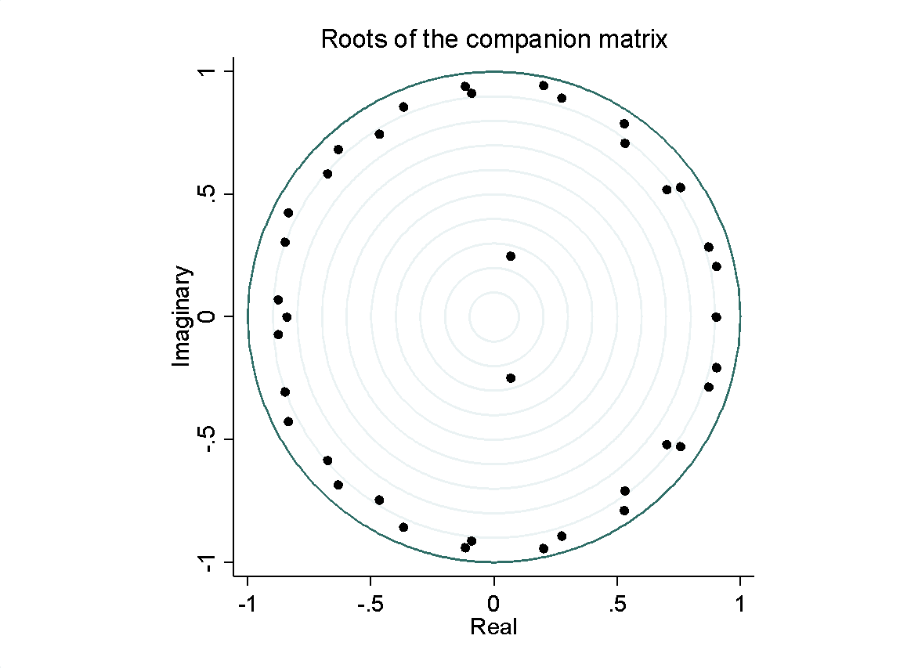
Figure 1 VAR stability
Since all eigenvalues are in the interior of the unit circle in Figure 1, it can be reasonably be informed that VAR model is feasible and data are stationary.

Impulse Response
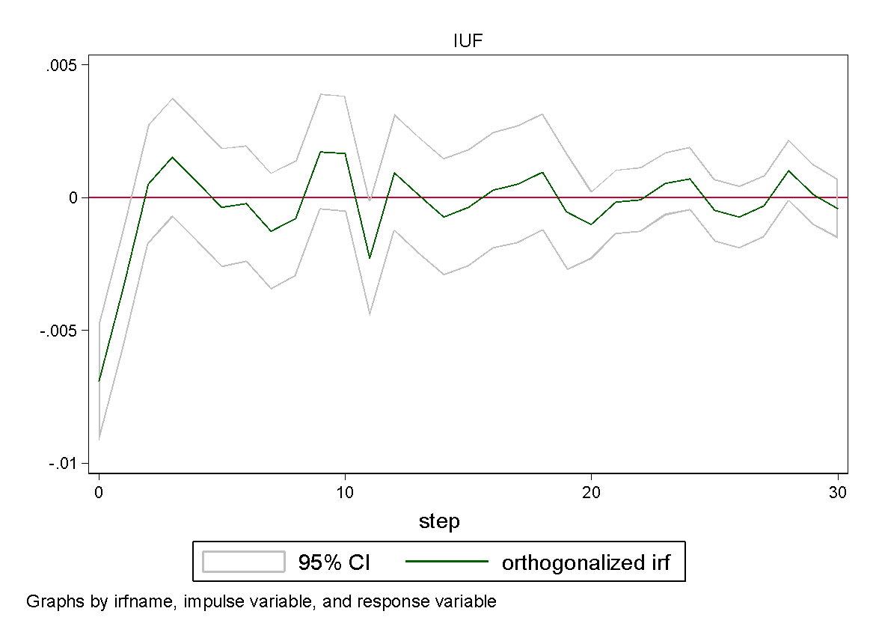
Figure 2 Impulse response function
The impulse response graph, Figure 2 revealed how much a unit impulse caused the other variables to change over time
From the theoretical analysis, it is certain that the Fed's interest rate hike will lead to higher demand for the US dollar in international lending and international financial markets, and further lead to a higher exchange rate. However, the impact of higher exchange rate on TSMC may lead to the following economic consequences.
First, this paper assumes the existence of rigidity in the short run in the prices of firms' products by referring to the producer theory of microeconomics which is a weak assumption, i.e., it is difficult for Apple to adjust its product prices in the short run in response to the exchange rate. TSMC, as a large, US-listed company with multinational operations, has its major revenues, financial reports, etc. in US dollars. A stronger dollar means that the company's operating income in foreign countries will depreciate, and from this aspect, the Fed's interest rate hike could be a negative for TSMC. In addition, higher interest rates will definitely promote domestic savings in the US and discourage consumption. This is also one of the bearish factors.
Secondly, the international financial market has increased its holdings of U.S. dollars, which may flow into the stock market or bond market and increase the demand for stocks, i.e., there is a net capital inflow into the U.S. stock market, which in turn may raise the U.S. stock prices.
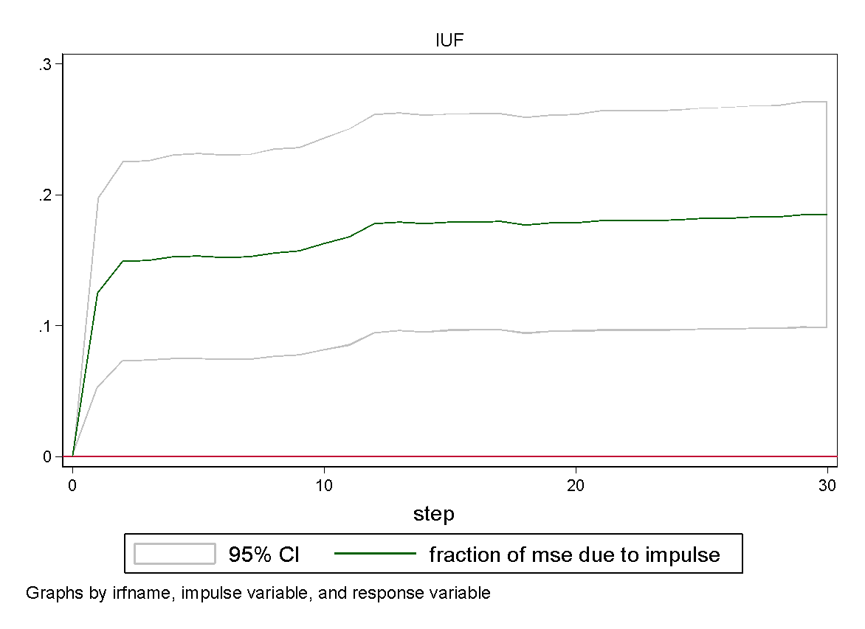
Figure 3 Cumulative response function
Based on the above theoretical analysis, it is difficult to directly determine in this paper whether net capital inflows or foreign currency depreciation dominate the impact on TSMC stock prices in the context of the Fed's interest rate hike.
From the estimation results of the impulse responses, a one-unit exchange rate shock in period t=0 has a negative impact on TSMC's return in period t=0, and then oscillates around the value of 0, making it difficult to determine the net impact.
Accordingly, this paper further uses the cumulative response function to calculate the total impact of the current period shock on the next 30 periods.

ARMA Identification
PACF | ACF
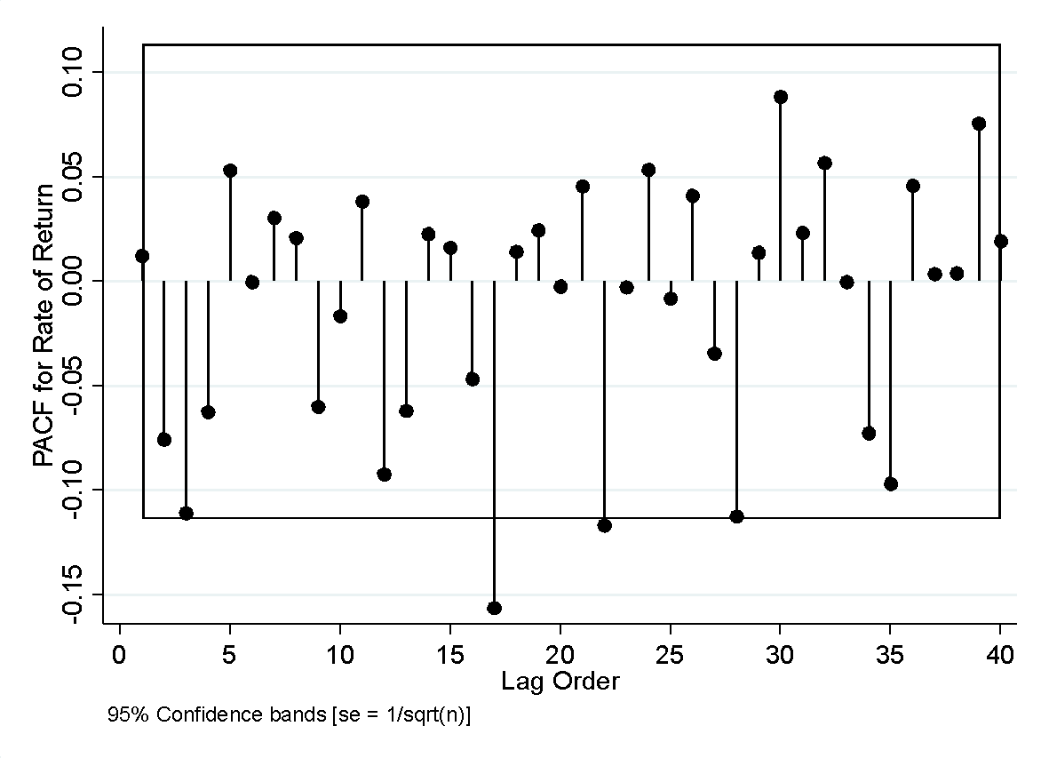 | 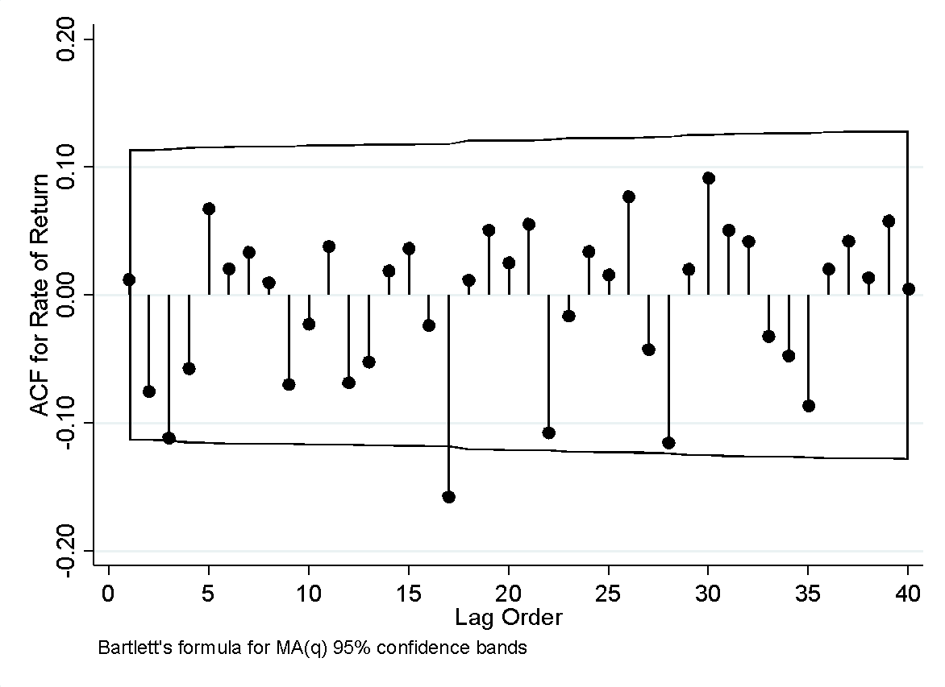
Figure 4 PACF and ACF
ACF is the autocorrelation function that give the value of auto correlation of any series with its lagged value and PACF is a partial auto-correlation function. From Figure 4, the most of the value of the return rates in PACF and ACF graph are in the 95% confidence interval and it is an indicator of the significance threshold. Therefore, PACF and ACF reveals coefficients are autocorrelated.
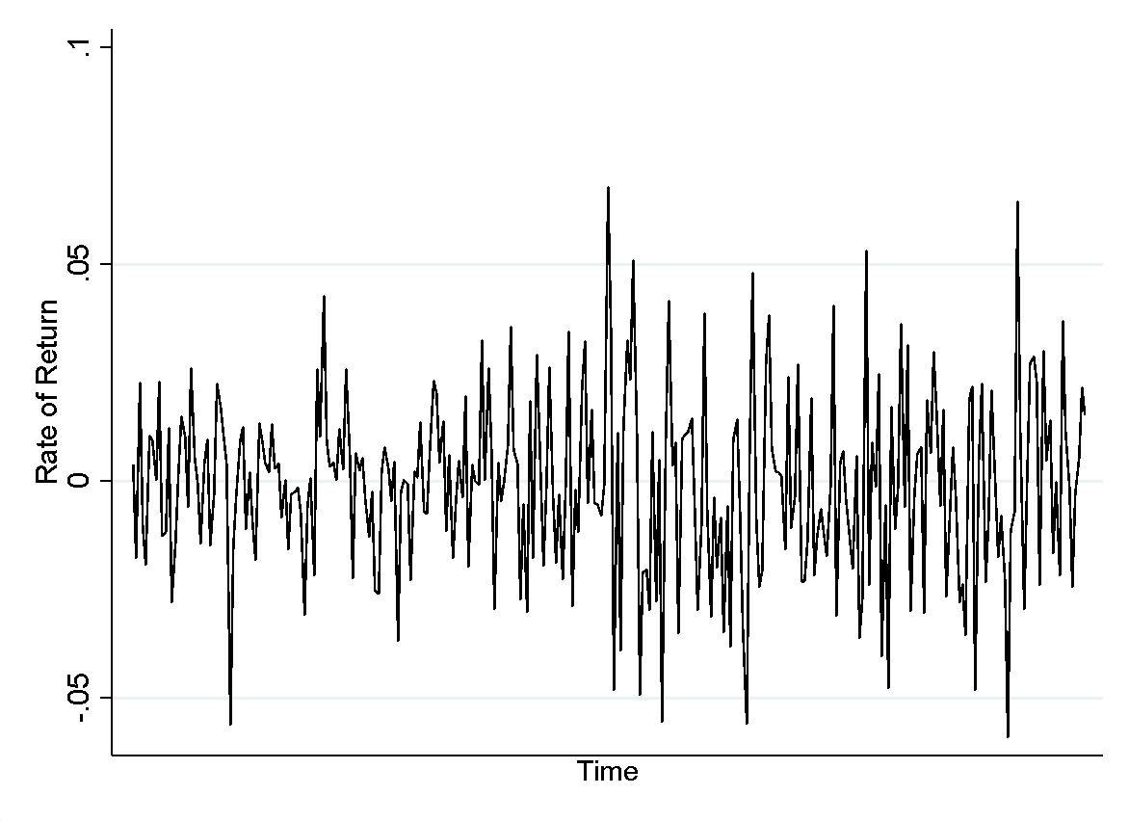
Figure 5 Yield trend
From the time series plot, Figure 5, TSMC returns show a more pronounced aggregation, but whether the effect is statistically significant requires further empirical testing.

ARMA-GARCHX Results
From the estimation results of the ARMA-GARCHX model (Table 3), the ARCH term is insignificant and the GARCH term is significant at the 1% level, indicating that TSMC returns have significant conditional heteroskedasticity and can be modeled GARCH.
From the estimation results of the external explanatory variables, the coefficient of exchange rate is negative and insignificant, indicating that there is no significant effect of exchange rate changes on TSMC's daily volatility.
Table 3 ARMA-GARCHX estimation results
 | Coefficient | Std. err | z | P>|z|
Mean equation
AR, L17 | -0.0350 | 0.4544 | -0.08 | 0.939
MA, L17 | -0.1158 | 0.4579 | -0.25 | 0.800
Constant | -0.0006 | 0.0009 | -0.65 | 0.516
Variance equation
Exchange rate | -250.9468 | 368.3543 | -0.68 | 0.496
ARCH, L1 | 0.0324 | 0.0200 | 1.62 | 0.105
GARCH, L1 | 0.9557 | 0.0283 | 33.72 | 0.000
Constant | -12.1953 | 1.1061 | -11.03 | 0.000

Discussion
In light of the fact that a rise in Fed funds rates has a material impact on the state of the global economic market, Rahman's contention has been proved to be correct. [3] The increase in interest rates by the Federal Reserve will cause an increase in the demand for US dollars on the international financial market, which in turn will cause an increase in the value of the currency exchange rate. According to the findings of this research study, the net capital inflow on the stock market for TSMC has a significant impact than foreign currency depreciation influences the price of TSMC stock when the Fed raises interest rates. TSMC has a solid and healthy development trend, as evidenced by the fact that the company anticipates a bigger amount of impact coming from the net capital inflow. Because there is a positive flow of net money onto the stock market, it is reasonable for the investment to be made in the semiconductor industry, particularly TSMC.

Conclusion
The increase in interest rates by the Fed has a complicated impact on global markets. However, there will certainly be a rise in the demand for US dollars on the worldwide financial market as a result of the Fed's decision to raise interest rates. This might result in a monotonous rise in the currency rate. However, the rise in the exchange rate will have a wide-ranging and complex effect on the semiconductor industry as a whole, particularly on TSMC. Considering that a stronger dollar would result in lower operational revenue for businesses doing business in other nations, the Federal Reserve's decision to raise interest rates might have a negative impact on TSMC. Additionally, higher interest rates will inevitably encourage individuals to save more money while simultaneously reducing their level of spending. However, as a result of an increase in the amount of US dollars held in the financial market, this portion of the funds may flow into the stock market or the bond market, which will increase the demand for stocks. This means that there is a net capital inflow in the US stock market, which may result in an increase in the stock price in the United States. This research has predicted a clear future trend of TSMC by constructing different models. Net money onto the stock market will be a dominant factor rather than others and lead to the increasing trend of TSMC stock market in the future.

References
- Bown C P. How the United States marched the semiconductor industry into its trade war with China[J]. East Asian Economic Review, 2020, 24(4): 349-388.
- Bivens J. The Fed’s rate hike is not surprising, but it is disappointing[J].
- Rahman M O. Aftermath of Fed Rate Hike[J]. 2017.
- Ogawa E, Shimizu J, Luo P. Effects of US Interest Rate Hikes and Global Risk on Daily Capital Flows in Emerging Market Countries[M]. RIETI, 2019
- Feldstein M. Why is the Fed still raising interest rates?[J]. Project syndicate, 2018.
- Ogawa E, Shimizu J, Luo P. Effects of US Interest Rate Hikes and Global Risk on Daily Capital Flows in Emerging Market Countries[M]. RIETI, 2019.
- Jin C, Wu Z, Yu J. Analysis on the Influence of FED Interest Rate Adjustment on China’s Economy[C]//2022 2nd International Conference on Enterprise Management and Economic Development (ICEMED 2022). Atlantis Press, 2022: 1127-1135.
- Eastmoney. [2022-09-12]. https://choice.eastmoney.com
- Yahoo Finance. [2022-09-13]. finance.yahoo.com
- Sims C A. Macroeconomics and reality[J]. Econometrica: journal of the Econometric Society, 1980: 1-48.
- Engle R F. Autoregressive conditional heteroscedasticity with estimates of the variance of United Kingdom inflation[J]. Econometrica: Journal of the econometric society, 1982: 987-1007.
- Bollerslev T. A conditionally heteroskedastic time series model for speculative prices and rates of return[J]. The review of economics and statistics, 1987: 542-547.

